SYSTEM DESIGN
My Daily Learning + Blog Journal
DAY 01 | 22 SEPTEMBER 2026
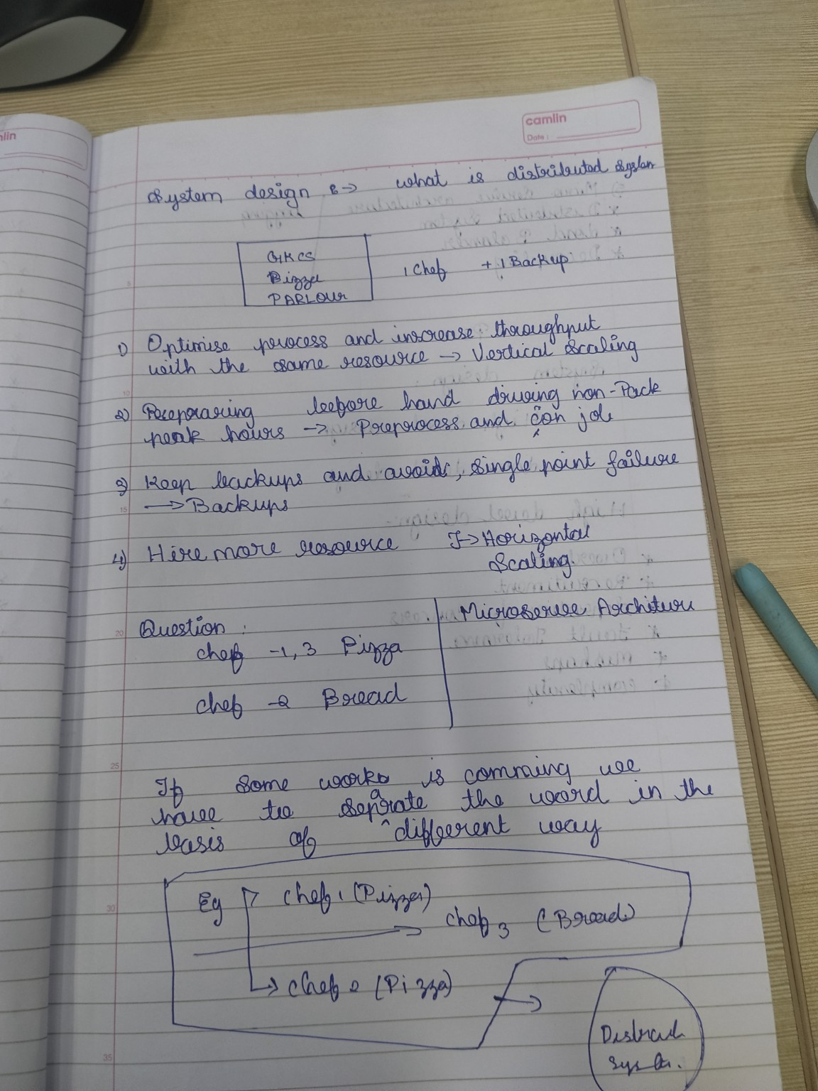
Original handwritten notes — Page 1
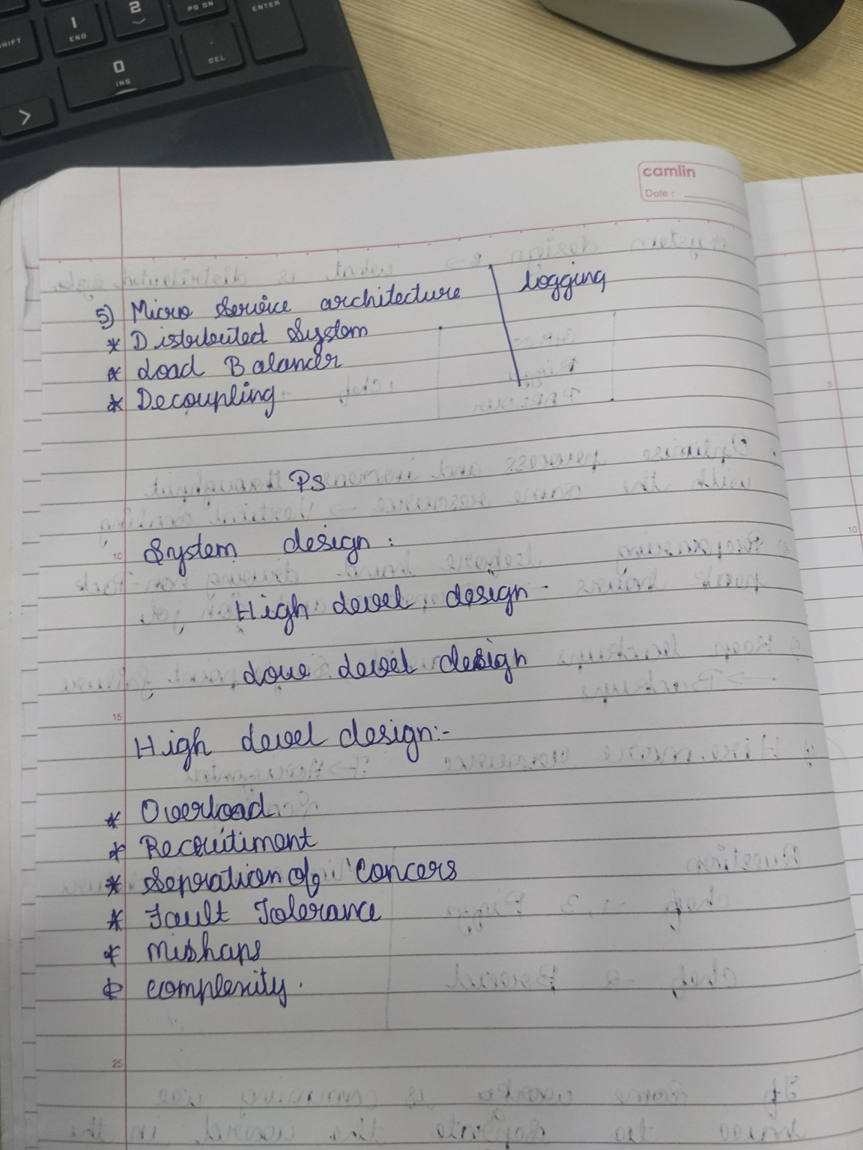
Original handwritten notes — Page 2
The original images are kept in colour so the learning record stays personal and authentic.

How I Want to Explain What I Learn
I do not want my learning notes to look like copied textbook definitions. When I write about a technical topic, I want to explain it in the way I would explain it to a fresher sitting beside me.
So each day I am going to follow a simple pattern: first understand the idea, then explain it in my own words, then give a real example, then show a small diagram, and finally write what I still need to practise.
My writing rule
If I cannot explain a concept without reading the definition again, I probably have not understood it well enough yet.

DAY 01 — SYSTEM DESIGN BASICS
Date | 22 September 2026
Topic | System Design
Level | Foundation / Beginner
Main goal | Understand how software systems are structured, scaled, separated and made more reliable.

1. First: What Do We Mean by System Design?
Before learning system design, I want to remove one common misunderstanding: system design is not just drawing boxes on a diagram.
Suppose I build a very small application. I might have one Python program, one database and a few API endpoints. That can be enough in the beginning. But imagine the application suddenly has thousands or millions of users. Now I have to think about traffic, database load, failures, backups, response time, security, monitoring and how to add more capacity.
That thinking process is what I am learning as system design. I am trying to decide what components I need, what each component should do, how they communicate, where data should live, and what should happen when something goes wrong.
User → Application → Services → Database / External Services
How I would explain this to a fresher
System design is basically planning the full structure of an application before the application becomes too big to manage as one simple program.

2. Why Do We Even Need System Design?
If an application has only a few users, almost any reasonable design may work. The interesting problems appear when the application grows.
- More users send requests at the same time.
- One server may not have enough CPU or memory.
- The database can become overloaded.
- A server or service can fail.
- Some operations take much longer than others.
- Different teams may need to change different parts of the application.
- We need to recover data if something is deleted or damaged.
So when I study system design, I am really learning how to think about these problems before they become production problems.

3. Distributed System — The Basic Idea
A distributed system means that different parts of the application are running on different computers, processes or services and communicate with one another.
My Application
|
+-----------+-----------+
| | |
Service A Service B Service C
| | |
Data Data External API
For example, an online shopping application might have separate areas for orders, payments and delivery. They can communicate over a network rather than being one giant piece of code.
The benefit is that I can potentially scale or deploy parts independently. The trade-off is that I now have network communication, more failure points, more monitoring and more things to manage.
My fresher explanation
Instead of one giant shop where one person does everything, think of several counters with different jobs. They work together, but each counter has its own responsibility.

4. Scaling — What Happens When Users Increase?
Scaling means increasing the capacity of a system so it can handle more work. The 'work' could mean users, API requests, transactions, files or data.

4.1 Vertical Scaling
Vertical scaling means upgrading the existing server. I am keeping the same machine but giving it more resources.
Existing server
4 CPU cores + 8 GB RAM
↓
16 CPU cores + 32 GB RAM
This is easy to understand and often simple to implement. But a single machine has a limit. There is also a risk that the application depends too heavily on that one machine.

4.2 Horizontal Scaling
Horizontal scaling means adding more servers or application instances.
Users
|
v
Load Balancer
/ | \
v v v
Server 1 Server 2 Server 3
Instead of asking one server to do all the work, I distribute the work across multiple servers. This is a major building block of scalable distributed systems.
Simple memory trick
Vertical = make the machine bigger. Horizontal = make the number of machines bigger.

5. Vertical vs Horizontal Scaling
Question | Vertical | Horizontal
What changes? | Machine resources | Number of machines
Example | More RAM / CPU | More application servers
Simple to start? | Usually yes | Requires traffic distribution
Main limitation | One machine's capacity | Architecture becomes more distributed

6. Preparing Before Heavy Traffic
One point in my handwritten notes was about preparing before a workload spike. This is important because waiting until the system is already overloaded is too late.
Imagine a food-ordering application. At 12:30 PM, many people start ordering lunch at the same time. If I know this pattern in advance, I can prepare the system before the traffic arrives.
- Cache frequently requested information.
- Pre-process work that does not need to happen during the request.
- Increase application capacity before a predictable spike.
- Distribute traffic across multiple instances.
- Move slow background work away from the immediate user request when appropriate.

7. Backup and Single Point of Failure
A Single Point of Failure, or SPOF, is a component where one failure can cause a major part of the system to stop working.
Application
|
v
One Database
X ← database fails
If the application depends on only one database and that database fails, the application may no longer be able to read or write the required data.
Backups give us a recoverable copy of data. Redundancy gives us additional components. These are related ideas, but they are not exactly the same.
Application
|
Primary Database
|
Replica / Backup
Important distinction
A backup is mainly about recovery. Redundancy can help a system continue operating when a component fails. The exact design depends on the system's requirements.

8. Load Balancer — The Traffic Controller
Once I have multiple application servers, I need a way to decide where each incoming request should go. That is where a load balancer comes in.
Clients
|
v
+----------------+
| Load Balancer |
+----------------+
| | |
v v v
App 1 App 2 App 3
The load balancer receives requests and routes them to available servers. This helps prevent one server from receiving all the traffic.
In many architectures, load balancers can also perform health checks. If an application instance is unhealthy, it can be removed from normal traffic routing until it becomes healthy again.

9. Microservices — Why Split an Application?
Microservice architecture is an approach where a larger application is divided into smaller services, usually around separate business responsibilities.
Food Platform
|
+------------+------------+
| | |
Orders Payments Delivery
For example, the Order Service can focus on orders, Payment Service can focus on payments, and Delivery Service can focus on delivery.
The important point is not simply 'make many services'. The important point is separating responsibilities so that parts of the system can be developed, deployed or scaled independently when that is useful.
There is also a trade-off. Microservices can introduce network calls, distributed debugging, service discovery, deployment complexity, monitoring requirements and data consistency challenges.
How I would tell a fresher
Microservices are like dividing a big department into smaller teams. Each team owns a particular job. The teams still need a good way to communicate.

10. Decoupling — Reducing Direct Dependency
Decoupling means reducing unnecessary direct dependency between components.
Tightly coupled
Service A → Service B → Service C
A more loosely coupled design can use a message queue for certain asynchronous workflows.
Service A → Message Queue → Service B
└────→ Service C
This does not mean that services never communicate. It means we carefully design how they depend on one another.

11. Logging — How Can I Know What Happened?
Once an application becomes large, I cannot sit and watch every request manually. I need records of important events. That is the role of logging.
2026-09-22 16:30:01 | user=101 | order=5001 | status=CREATED
If a user says, 'My order failed', useful logs can help me trace what happened. Logs are also useful for debugging, monitoring, failure investigation and understanding application behaviour.

12. High-Level Design (HLD)
High-Level Design is the big-picture view. When I draw an HLD, I am not worrying about every class and method yet. I am showing the major building blocks and how they communicate.
User
|
v
Load Balancer
|
+---- App Server 1
+---- App Server 2
|
Database
At HLD level, I ask questions like:
- What are the major components?
- Where does the data live?
- How does the client reach the backend?
- How does traffic get distributed?
- Which external systems are involved?
- What happens if a major component fails?

13. Low-Level Design (LLD)
Low-Level Design takes one of those components and goes deeper. Here I start thinking about classes, interfaces, methods, objects, database tables and detailed API behaviour.
User
├── id
├── name
├── email
└── login()
So the easiest way I remember it is: HLD is the map of the city; LLD is the detailed plan for the individual buildings and roads.

14. HLD vs LLD — In My Own Words
HLD — BIG PICTURE | LLD — INSIDE THE COMPONENT
Architecture | Implementation
Services | Classes / interfaces
Major data flow | Detailed logic
System components | Objects / methods
How pieces connect | How each piece works

15. The Quality Questions I Should Ask During Design
Scalability — If the number of users becomes larger, how will the system handle it?
Availability — Can users still access the system when some components fail?
Fault tolerance — Can the system continue or recover when failures happen?
Reliability — Does the system behave correctly and consistently?
Performance — How quickly does it respond under expected workload?
Complexity — Will this architecture become difficult to operate and maintain?
Cost — What infrastructure and operational resources will this design require?

16. My Pizza and Bread Example
The example in my handwritten notes is simple, but it helped me understand workload separation.
Chef 1 → Pizza
Chef 2 → Bread
Chef 3 → Pizza
If pizza orders increase, I may need more pizza capacity. I do not necessarily need to increase bread capacity by the same amount.
In software, I can think about workloads in a similar way. If one business function receives much more traffic than another, separating that function can make it possible to scale the busy part without scaling everything.

17. What I Actually Learned Today
Today I did not just learn a list of system design terms. I started seeing why these ideas exist.
A small application can begin with one server. As it grows, I may need more capacity. That leads me to scaling. Once I have multiple servers, I need traffic distribution, which leads to load balancing. If a component can fail, I need to think about redundancy and recovery. If the application becomes large, I may separate responsibilities into services. Once there are many services, communication and observability become important, which brings me to decoupling and logging.
That chain of reasoning is what I want to keep in my notes. I do not want to memorize isolated definitions; I want to understand why one design decision leads to another.

18. Questions I Can Use to Test Myself
- What problem is system design trying to solve?
- When would I use vertical scaling?
- What does horizontal scaling change?
- Why would I need a load balancer?
- What exactly is a Single Point of Failure?
- What is the difference between a backup and redundancy?
- Why might an application be split into microservices?
- What new problems can microservices introduce?
- What does decoupling mean?
- Why do production systems need logging?
- What belongs in HLD?
- What belongs in LLD?

19. Hands-On Exercise For Today
I will design a simple food-ordering system twice. First, I will design the smallest possible version. Then I will redesign it after imagining that traffic has increased.
Version 1
Users → Application → Database
Version 2
Users → Load Balancer → App 1 / App 2 / App 3 → Database
After drawing it, I should be able to explain:
- Where is the bottleneck?
- What happens if App 2 fails?
- What happens if the database fails?
- Where can I add a backup?
- Which workload could become a separate service?
- Where would I add logging?

20. My Daily Reflection
What I understood clearly:
________________________________________________________________________
________________________________________________________________________
What I found confusing:
________________________________________________________________________
________________________________________________________________________
What example helped me:
________________________________________________________________________
________________________________________________________________________
What I need to practise:
________________________________________________________________________
________________________________________________________________________
What I want to learn next:
________________________________________________________________________
________________________________________________________________________

BLOG DRAFT — DAY 01
I started learning system design today, and one thing became clear very quickly: system design is not just about drawing architecture diagrams.
At the beginning, I was thinking about it as a technical topic with terms like horizontal scaling, load balancing, microservices and HLD. But when I connected the terms to a simple application, the ideas started making more sense.
Imagine I build a small application with one server and one database. If only a few people use it, that may be completely fine. But if the number of users suddenly grows, the same design can become a problem. The server has limited CPU and memory, and the database can also become overloaded.
This is where scaling comes in. Vertical scaling means making the existing server stronger. Horizontal scaling means adding more servers. Once there are multiple servers, I need a way to distribute requests between them, which is where a load balancer becomes useful.
I also learned about Single Points of Failure. If my application depends on one important component and that component fails, the application can be affected. Backups and redundancy are two ways of thinking about failure, although they solve different problems.
The pizza and bread example from today's notes helped me understand another idea: not every workload needs the same amount of capacity. If pizza orders become much higher than bread orders, I should be able to increase pizza-processing capacity without automatically increasing everything else.
That connects nicely to microservices and workload separation. But I also learned that microservices are not magic. Splitting an application creates more communication and operational complexity, so the decision has to make sense for the system.
Finally, I learned HLD and LLD. HLD gives me the overall architecture, while LLD takes me inside the individual components. For now, I am treating these as foundations. My goal is to move from simply understanding the words to actually designing systems and explaining why I made each decision.

Possible Blog Titles
- My First Day Learning System Design: From One Server to Distributed Systems
- System Design for a Beginner: What I Understood on Day 1
- Vertical vs Horizontal Scaling: The First System Design Concept I Learned
- Why Load Balancers, Backups and Microservices Exist

DAILY TEMPLATE — USE THIS FOR EVERY FUTURE DAY
The idea is to keep the same structure every day, while changing the explanations, diagrams, examples and reflections.
DAY / DATE
________________________________________________________________________
________________________________________________________________________
MAIN TOPIC
________________________________________________________________________
________________________________________________________________________
WHAT I LEARNED TODAY
________________________________________________________________________
________________________________________________________________________
HOW I WOULD EXPLAIN IT TO A FRESHER
________________________________________________________________________
________________________________________________________________________
REAL-WORLD EXAMPLE
________________________________________________________________________
________________________________________________________________________
MY DIAGRAM
________________________________________________________________________
________________________________________________________________________
IMPORTANT TERMS
________________________________________________________________________
________________________________________________________________________
WHAT CONFUSED ME
________________________________________________________________________
________________________________________________________________________
HANDS-ON PRACTICE
________________________________________________________________________
________________________________________________________________________
QUESTIONS I CAN ANSWER NOW
________________________________________________________________________
________________________________________________________________________
WHAT I NEED TO REVISE
________________________________________________________________________
________________________________________________________________________
MY PERSONAL TAKEAWAY
________________________________________________________________________
________________________________________________________________________
BLOG TITLE
________________________________________________________________________
________________________________________________________________________
BLOG DRAFT
________________________________________________________________________
________________________________________________________________________
NEXT DAY PLAN
________________________________________________________________________
________________________________________________________________________

FONT GUIDE FOR MY BLOG JOURNAL
I am intentionally using different fonts by purpose, rather than randomly mixing fonts:
- Georgia — main titles and major section headings.
- Trebuchet MS — subheadings, callouts and personal-note labels.
- Calibri — normal explanations and long reading sections.
- Consolas — code, architecture diagrams and command-like examples.
This keeps the document feeling personal and designed while still being easy to read. The handwritten photos remain in their original colour so the journal still feels like a real learning record rather than a generated report.

